# **Condition:** **Azure VNET Peering disconnected**

**Condition**

**Description:**

* Virtual network peering enables you to seamlessly connect Azure [virtual networks](https://docs.microsoft.com/en-us/azure/virtual-network/virtual-networks-overview).
* Once peered, the virtual networks appear as one, for connectivity purposes.
* The traffic between virtual machines in the peered virtual networks is routed through the Microsoft backbone infrastructure, much like traffic is routed between virtual machines in the same virtual network, through private IP addresses only.
* Virtual network peering exists, all subnets within the virtual network have routes with next hop type VNet peering, for each address space in each peered virtual network.
* Ideal VNET peering state is “connected”.

**Impact:** If your VNet peering connection is in a *Disconnected* state, it means one of the links created was deleted & there is possibility you can not communicate with resource

**Criticality:** Critical Impact

**Frequency:** 20 min

**Trigger Details**

**Trigger Condition:** Alert will be triggered if VNET Peering state is **“disconnected”**.

**Method to capture trigger point:**

* REST API can be used to capture the alert trigger point.
* REST API URI is as mentioned below:

[https://management.azure.com/subscriptions/{subscriptionId}/resourceGroups/{resourceGroupName}/providers/Microsoft.Network/virtualNetworks/{virtualNetworkName}/virtualNetworkPeerings?api-version=2019-09-01](https://management.azure.com/subscriptions/%7bsubscriptionId%7d/resourceGroups/%7bresourceGroupName%7d/providers/Microsoft.Network/virtualNetworks/%7bvirtualNetworkName%7d/virtualNetworkPeerings?api-version=2019-09-01)

* Reference link:

<https://docs.microsoft.com/en-us/rest/api/virtualnetwork/virtualnetworkpeerings/list>

* Alert will be triggered if “peeringState" is "Disconnected”.

**Sample Output from API:**

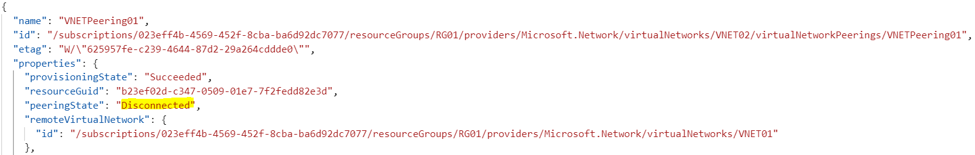

**Alert Details**

**Alert Category:** Virtual Network

**Details required along with Alert:**

1. Subscription ID.
2. Resource Group Name.
3. Virtual Network Name.
4. VNET peering Name.